QA Fundamentals and Manual Testing Regular Exam



# Part I – Story Spoil Web Application

You are provided with a web application, **Story Spoil**, along with the specification of the requirements. The primary objective of the exam is to ensure the App functions as expected according to the provided use cases. This involves **creating test cases for each use case**. It also includes the **detection and detailed documentation of any identified bugs**. You have to document all your work in the provided **Test Management and Bug Tracker Template**.

## Software Requirements

### Introduction

#### Purpose

The objective of this document is to provide a description of the Story Spoil application (also referred to as Story Spoil or The App). It will present an overview of the key functionalities.

#### Scope

This document includes high-level descriptions of the **basic functionalities of Story Spoil**, such as user registration, login, profile editing, spoiler creation and management. It does not cover any special user (Administrator) functionalities.

### Overall Description

#### System environment

The App hosts two primary actors: **unregistered/non-logged** users and **registered/logged users**. Both can access their respective parts of the application via the internet on the following url:

[**https://d24hkho2ozf732.cloudfront.net/**](https://d24hkho2ozf732.cloudfront.net/)

#### Key Features

**Unregistered/non-logged users** have access only to the Home page of The App, with the option to either **SIGN UP** or **LOG IN**. On the other hand, **registered/logged users** have access to the **main functionalities**, including **Profile editing**, **Spoiler creation**, and **Spoiler management**.

##### Home Page for unregistered / non-logged users

The **Home Page** is the main gateway into The App. It contains a **navigation bar** (also referred to as **Navbar**) **on top**, with **StorySpoil Home Page** link on the left and **SIGN UP** and **LOG IN buttons** on the right. The **Home Page is scrollable** and the central focus is to encourage users to share their stories.

Below, there are three sections promoting The App experience. Each consists of motivational phrase, short description and corresponding picture: **Summarize the Story**, **Upload a Picture**, **Ready to Spoil a Story?**.

At the bottom, there is a **Copyright Footer**, which upon click, leads to the **copyright page** which includes the name of the copyright owner, the year of copyright, and any other relevant copyright information.

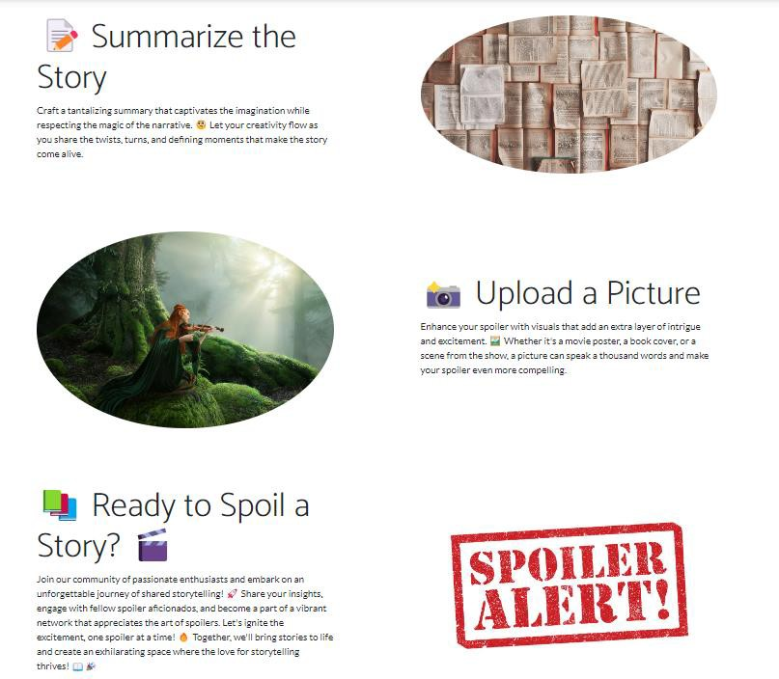

##### Sign Up Page

The **Sign Up page** is accessed from the Home page **via SIGN UP button** on the Navbar. It contains **registration form** with fields for entering **Username**, **Email**, **First Name**, **Middle Name**, **Last Name**, **Password**, and **Repeat Password**. The form also includes a **SIGN UP button** to submit the form. There is also a **LOG IN HERE button** for registered users, which redirects to **LOG IN page**.

The acceptable requirements for each field on the registration form are specified as follows:

**Username:** A 2-30 character field, accepting all character types.

**Email:** Requires a valid email, 6-254 characters long.

**First Name:** A 2-60 character field, accepting all character types.

**Middle Name:** A 2-60 character field, accepting all character types. Not required.

**Last Name:** A 2-60 character field, accepting all character types. **Password:** Any characters are acceptable, with a length of 6-30 characters **Repeat Password:** Must match password.

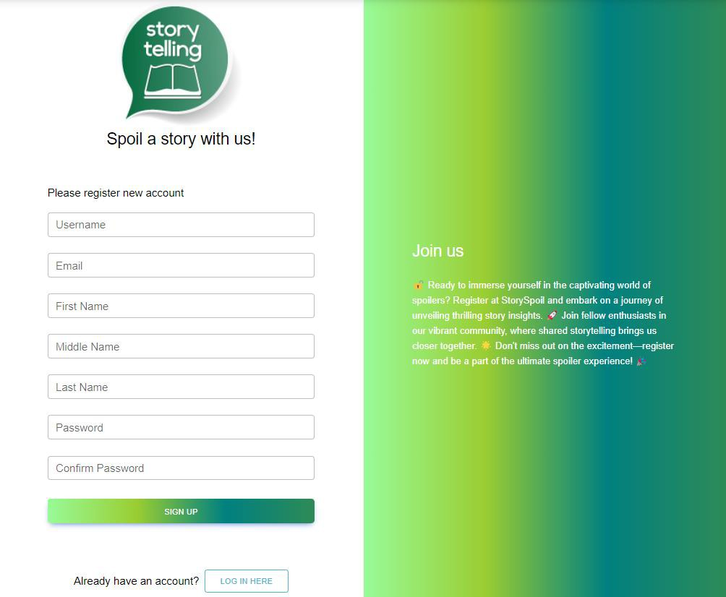

##### Log In Page

The **Log In page** can be reached **from the Navbar LOG IN button on the Home page**. The page provides fields for **Username** and **Password**, as well as a **Forgot password** option, also a **LOG IN button** and a **CREATE NEW button**, which leads to **Sign Up page**.

**Forgot Password** functionality leads to a Restore password page, where the password can be restored by verified email.

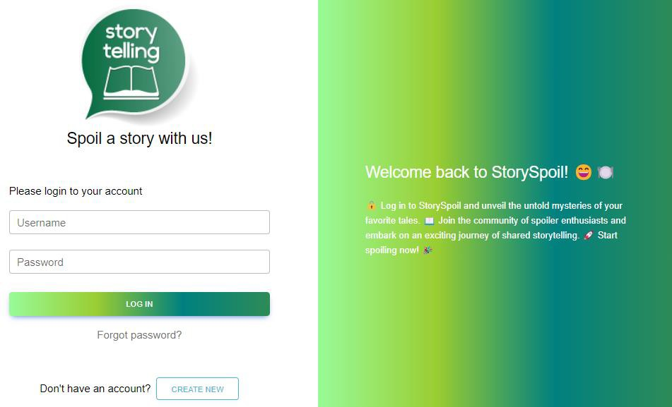

##### Home Page for logged users

Once a user is **logged in**, they are redirected to a different version of the **Home page**. The page includes a **Navbar on top**, with links to the **User's profile** and **Home page** on the left, and **CREATE SPOILER** and **LOGOUT buttons** on the right. The Home page includes **welcome message** with the **User's name**, and a **Search Field with a Search button**. If there is no spoiler added, the **Home page** is showing **No Spoilers Yet!** message and a **WRITE SPOILER button**, which leads to **Create Spoiler page**.

##### а. Home Page Search Functionality

The **search functionality** is available on **Home Page** and contains a **Search field and a Search button**. Users can enter **title** of the spoiler and click the Search button to initiate the search. The search functionality then filters the list of spoilers based on the provided titles. If there are no spoilers found, **There are no spoilers :(** message is shown again, as well as the **WRITE SPOILER button**, which leads to **Create Spoiler page**.

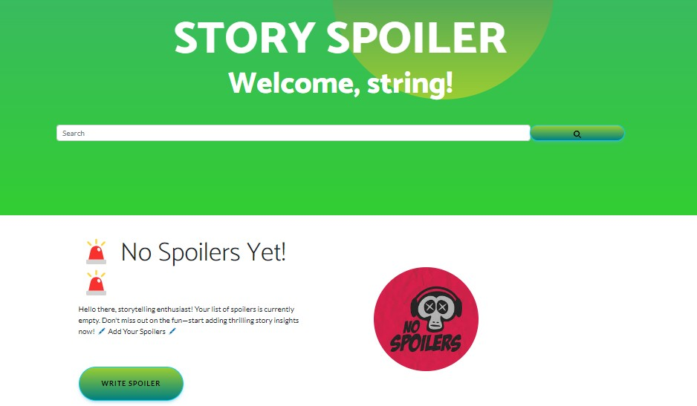

##### My Profile Page

This page is accessible for logged users **from the Navbar, top-left icon**. It includes **three sections**. On the left, by default an **empty profile picture, Username and EDIT button**. On the right are **User's attributes** - Full Name, Email and Total spoilers counter (zero by default). Below the User's attributes, the **About me section** is located (displaying "You haven’t written anything about yourself…" by default).

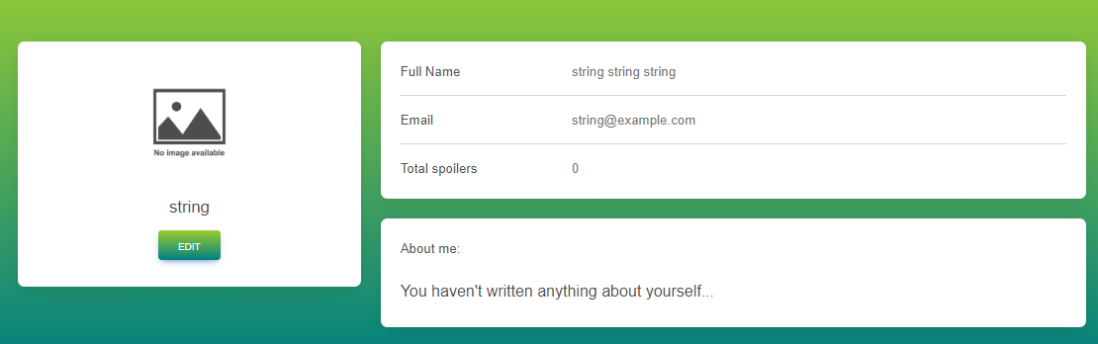

##### Edit Profile Info Page

Accessible from **EDIT button on My Profile page**, this page allows users to **edit their profile information**, including Profile picture (picture is not uploaded, but must be a valid URL of a picture, for example http:// jpg),

First name (max 60 characters length) , Middle Name (max. 60 characters length), Last name (max. 60 characters length), About me (max. 256 characters length).

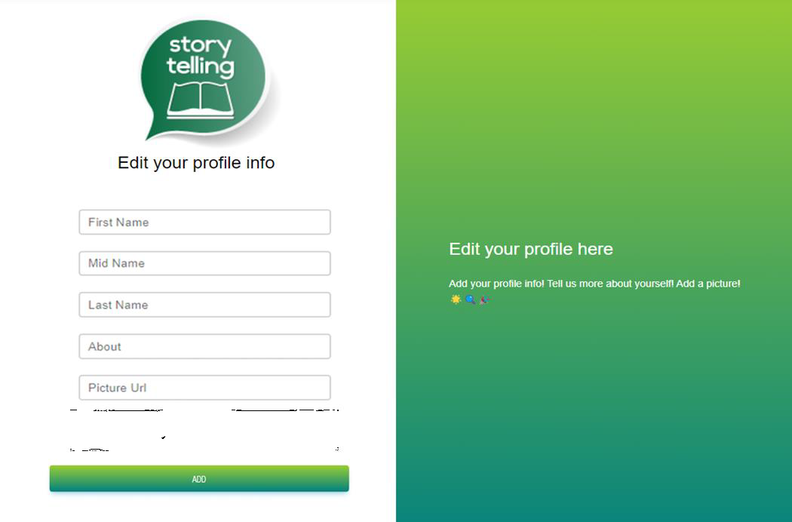

##### Create Spoiler Page

This page is accessible from the **Create Spoiler link on the navbar** and contains the following: **Story Title** field (max. 70 characters length), **Describe your story spoiler** field (max. 400 characters length), **Add a picture for the spoiler** field (picture is not uploaded, but must be a valid URL of a picture, for example http:// jpg) and

**CREATE button**.

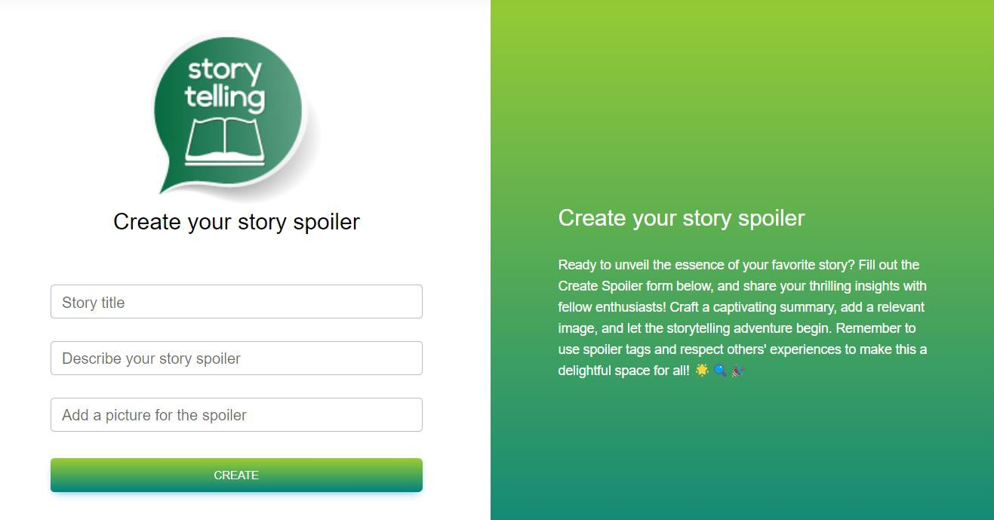

Upon **creating a Spoiler**, it redirects to **Home page for logged users**, where the new **added Spoiler is present** with it's attributes and buttons for **SHARE, EDIT, and DELETE**

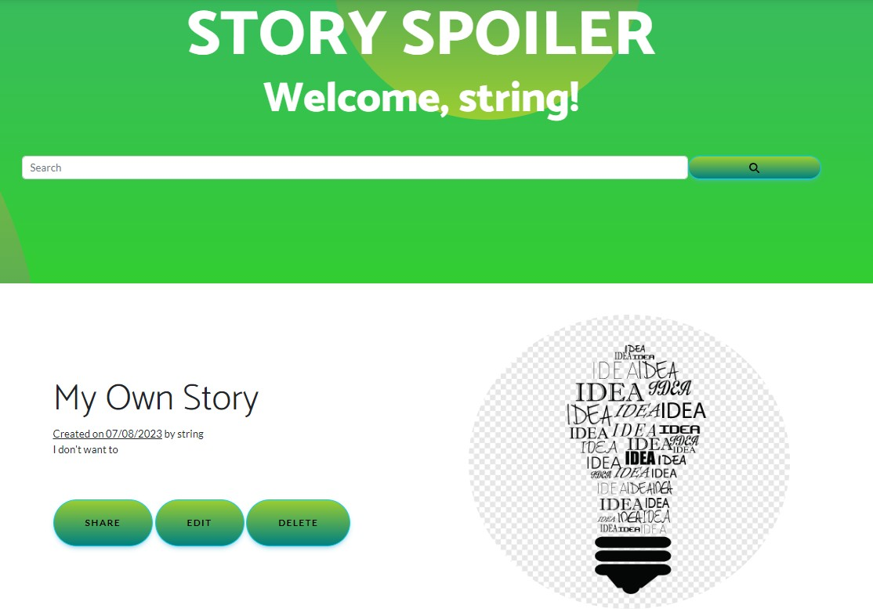

##### Story Spoiler Management

Story Spoiler Functionalities are **available from the Home Page**. Each created Story Spoiler has its own

**SHARE, EDIT and DELETE buttons**.

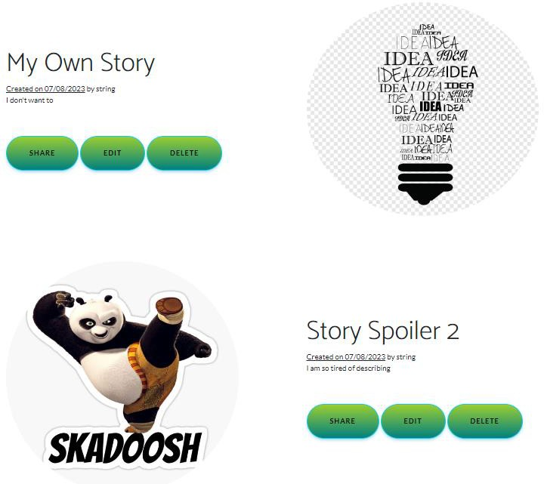

##### а. Share

Available after clicking on **SHARE button**.

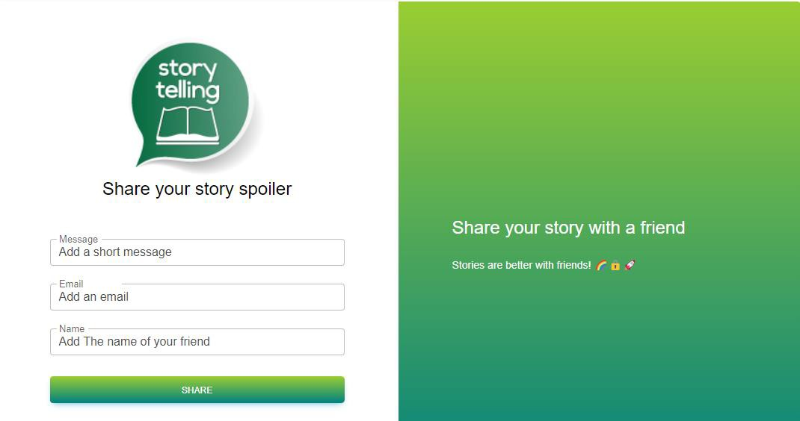

##### b. Edit

Available after clicking on **EDIT button**.

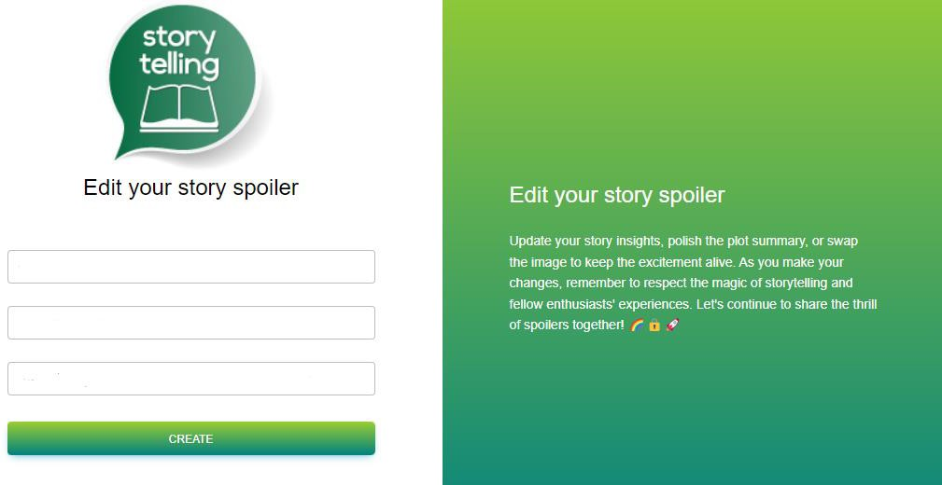

##### c. Delete

After clicking on **DELETE button**, the Spoiler is deleted and it disappers from the Home page.

## Functional Requirements

### Use Case 1 (Home Page)

Users should be able to access The Story Spoil App from its designated URL via the Internet, which should load the Home page, appropriate to the user's logged-in status (unregistered/non-logged or registered/logged).

### Use Case 2 (User Registration)

Unregistered users should be able to successfully go through the Sign Up process. This involves the utilization of fields such as Username, Email, First name, Middle Name, Last name, Password and Repeat Password, all subject to their respective constraints and character type acceptance.

### Use Case 3 (User Sign In)

Registered users should be able to successfully go through the Log In process. They should be able to log in using Username and Password.

### Use Case 4 (Profile Management)

Upon successful Log In, logged users should be able to navigate to their Profile page, edit their profile details, and view their Spoilers count. This involves the changing of profile picture inserted via URL, and editing of user data fields including First Name, Middle Name, Last Name and About me sections.

### Use Case 5 (Spoiler Creation)

Logged users should be able to navigate to the Create Spoiler page, where they can create a new Spoiler with a Title, Description, and a Picture (URL). After the Spoiler creation process, users should be redirected to the Home page, where the newly created Spoiler should be present.

### Use Case 6 (Spoiler Management)

On the Home page, logged users should see all their Spoilers listed. Each Spoiler should have options for Share, Edit, and Delete. If no spoilers have been created yet, a "No Spoilers Yet!" message should be displayed. Users also should have the option to search for spoilers, based on spoiler titles.

## Spoiler Web App Tasks

### Test Cases

You need to write **test cases for each of the 6 Use cases**. **Each Use case** should have at **least 2 Test Cases**.

You should write **at least 15 test cases**.

### Bug Reports

You should find and describe at least **5** bugs.

**2 of the bugs** should have **high priority** OR **blocking/critical severity**.

### Template

Use the provided **Test-Management-and-Bug-Tracking-Template.xlsx** to document your work.

# Part II – Story Spoil API

This section provides information about the **Story Spoil API endpoints** and their functionalities. It serves as a guide to understand how to interact with the Story Spoil API.

[**https://d5wfqm7y6yb3q.cloudfront.net/**](https://d5wfqm7y6yb3q.cloudfront.net/)

## Methods supported

You can see all the supported methods on the following link:

#### [Methods](https://d5wfqm7y6yb3q.cloudfront.net/)

The following endpoints are supported:

#### User

* + **POST /api/User/Create** – create a new user: post a JSON object in the request body, e.g.

**{ "userName": "string","firstName": "string", "midName": "string", "lastName": "string", "email": "**[**user@example.com**](mailto:user@example.com)**", "password": "string", "rePassword": "string" }**

* + **POST /api/User/Authentication**: log in an existing user (post a JSON object in the request body, e.g.

**{ "userName": "string", "password": "string"}**)

##### Access Token

* + When a user logs in, the response format is JSON object, e.g.

**{"userName": "string", "password": "1234567", "accessToken": "eyJhbGciOiJ…"}**

**NB! Access token is needed for all spoiler requests. It should be placed under the Authorization tab, Bearer Token option.**

#### Spoiler

All of the **following requests require Authotization**.

* + **GET /api/Story/All** – list all spoilers (empty request body)
  + **GET /api/Story/Search** – search spoilers by their name, requires

**queryParameter: ?keyword= storyTitle**

* + **POST /api/Story/Create** – create a new spoiler: post a JSON object in the request body, e.g.

**{ "title": "string", "description": "string", "url": "" }**

* + **PUT /api/Story/Edit/storyId** – replace the existing spoiler with the new one: post a JSON object in the request body, e.g. **{"title": "string", description": "string", "url": ""};**
  + **DELETE /api/Story/Delete/storyId** – delete existing spoiler;

## Story Spoil API Tasks: Postman Requests

Your task is to write **API requests** with Postman for certain RESTful API endpoints.

**You should organize your requests in a collection.**

### Log in to the API

**Send a POST request with your username and password**, that you previously created from the Story Spoil Web App. If properly executed, you will receive your access token as a part of the response body. Use it as a Bearer Token in the Authorization section for the next requests.

### Create a new spoiler

**Send a POST request with the attributes needed for creating a new spoiler**

Keep in mind that the full attributes in the JSON body are as follows:

**{ "title": "string", "description": "string", "url": "**[**http://...jpg**](http://.jpg/)**" }**

URL attribute is not mandatory, meaning that you can create a spoiler only with title and description. If you decide to use the url attribute, notice, that it has to point to a picture format or it can be left blank.

### List all spoilers

**Send a GET request to receive a list of all created spoilers**.

This request will return all spoilers created through your profile. So, if you created any spoilers via the Web App, they also will be listed. In the list of spoilers, find the idea that you just created. You will **need its id** for the next request.

### Change the title of the spoiler you created

**Send a PUT request with the attributes needed to replace the spoiler you created in task number 2. "Create a new spoiler".**

### Delete Spoiler

**Send a DELETE request with the attributes needed for deleting the spoiler you just edited.**

# How to submit your work

##### Create a .zip or .rar archive containing the following:

* + - Test-Management-and-Bug-Tracker.xlsx file with your work;
    - JSON file containing your collection of requests, created via Postman.
  1. **Upload your archive on the SoftUni website, into Regular Exam section.**

**Note: It’s the same as uploading your homework.**